Mgt501 final term subjective questions from last few semesters
Compiled by MEMON

mcqs handouts sa,mostly from last few chapters jo main ne sahi sa par ni paya due to time shortage😭

1.hrm department safety and health

2.transference and describe three types

3.briefly explain administrative discipline

4.briefly explain advantages and disadvantages of power

5.how to prevent voilence in organisation

6.wht advice you will give to your friends who is stressed up

7. how to deal with subordinate employees who was competent to get promotion but didn't get what will you tell him

MGT501 final exam on Sunday
1) When is straight pay and straight commission method used. Which is more appropriate?
2) question about health and safety.
3) How will MBO be used for appraisal of employees.
4) what advise will you give your friend who's not performing well at work due to stress.

Sort questions:
1. Why Herzberg's two factor theory is advanced then Maslow's theory or need.
2. Discribe goals of performance management
3. Job rotation and its types

Long questions :
1. Why executives have highly good salary than other employees
2. Your friend is in the condition of stress, how can you advise her to solve her problem
3. Why an assignment get failure internationally
My exam of mgt501 HR 3 Mar 21, 4:30 pm
1 HRD role in Training and Development
2 Reason for decline in union membership
3 what is Whistle blowing and why is it risky
4 What is upward and downward communication
5 what is transference learning principle give 3 training situations
6 A worker refuses to wear protective uniform, helmet, glasses, as it has been 15 years since last accident, do you agree with the worker or as a manager there should be disciplinary action taken against him

What Organization wants from HR professionals. 5
Job evaluation, which evalyluation metjod will be used in goven scenario 5
types of reward 3
how to make smoke free organization 5
how CEO promote comm in org 3
What is pol tactics, diff bw resource and (colaition, aliamce, network) 3.

MGT501 Paper 9:30AM
Defference b/w carrer development & employee development, difference b/w leader & manager, factor identifies kren stress conditions,
Health & Safety management se kafi sare question aye thy,
Details me read kr len lesson 32 to 38
Conceptual mcqs..

Mgt501
11 mar 0630 pm

5 marks. Job rotation n its types.

individual stolen coper was verbally warn and again he steels. As manager ur action.

Ear plugs not worn by worker during communication in production plant. Whats ur analysis on his habit

Customer appraisal is why important to check quality of a product. 5 marks.

Rest also conceptual. Subjective

.. Mcqs 60% from handout. 40% conceptual...

Mgt501 finall paper
1.Role ofTraining n development.
2. Negotiation.
3.Career development.
4.Health and safety
5.Advantages that organization can gain form HRM
6.Ak statement question tha... emplyoyee is argue with his manager about not wearing safely stuff ... strick action should taken against his or not

Total 39 questions...32 mcqs and baki 3 or 5 makx k questions
MGT501 Paper 9:30AM
Defference b/w carrer development & employee development,
difference b/w leader & manager, factor identifies kren stress conditions,
Health & Safety management se kafi sare question aye thy,
Details me read kr len lesson 32 to 38
Conceptual mcqs.
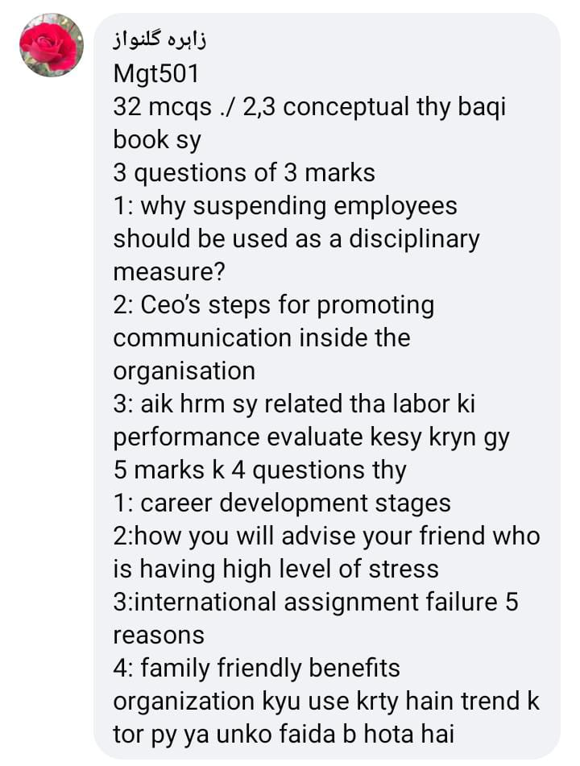

September 11, 2020 at 7:58pm
MGT501 VU Current Final Term Papers Spring 2020 (10 September onward)
Mgt501 Current finalterm paper
Question: Does indirect cost of an accident exceed the direct cost for an organization? Why or why not? 5 marks.

Question: An organization where operations are so diversified that finding the job similarity is quite difficult. HR Manager wants to develop an efficient strategy so that Job pricing become easy. As HR Manager, which Job Pricing Strategy would you suggest for this organization and why? 5 marks

Question: How an organization implements successful Career Management Practices? 5 marks.
Question: What organization should do to use monitoring devices to control theft while not intimidating or invading the privacy of honest employees? 5 marks

Question: How would you differentiate downward communication from upward communication? 5 Marks.
Question: Describe the purpose of disability of employee benefits program. 3 marks
Question: Why customer appraisal is important in measuring the quality of a company’s products? 3 marks
Question: Briefly describe the interactionist view in Conflict Thought. 3 marks
Question: Does any relationship exist between competency level and dependability of followers in a leadership process? 3 marks

Question: What a trainer can do to derive trainee motivation before and during training course? 3 marks

MGT501 Current Papers Final term Spring 2020
Career and development ka question tha?
McQ past papers main Sy b ay howy thy 30 %
Or aysy question thy k agr products making factory k ander employ ear k ander awaaz ko rokny Wala nai pyny to Kya behavior hai ye?
Stataionry benefits kon kon sy hai employee k?Zyda tar paper aysa he tha ek statement the jiss ka batana tha k is main kon sa sai hai or q

MGT501 current paper | 12-09-2020

Pahla kach mcqs past papers ma sa tha
1.Manager unable to create link between pay and performance?
2.how legimate power better than reward pawer.
3. Five stage of modal of start a career
4. differente between leader and manager
5. Three key factor employee behavior
6. HRM activities
7. Communication service provide to employees
8. How manager avoid to pay the employee. Five points
9. Employee performance sa annual incrementation kasa ho ga
10. Not remember.

September 19, 2020 at 10:04pm
Human Resource Management (Mgt501)
Today’s mine paper at 2:30pm
3 marks questions
1. Identify any 3 key consequences of behavior which either encourage or discourage people’s behavior in light of reinforcement theory.
2. Which three key factors determine the like hood of stress?
3. How organizations can prevent from corruption of power. . How organizations can prevent from corruption of power.
4. Provide an example of how personality traits of an employee can influence his/her performance appraisal.
5. In order to evaluate labors performance in an organization, HR department suggested to monitor monthly sales made by each of them. How would you evaluate this suggestion of HR department?
5 marks questions
1. One of your friend is suffering from high level of stress and he is not working well his work. What suggestions will you give to your friend in order to overcome his stress?
2. What benefit an organization can gain from safe and healthy employee.
3. What is transference (learning principle)? Describe three possible transfers training situations.
4. Why incentive-plans do fails? Provide reasons.

Mgt501
(Mcqs conceptual & tough most of them where they come no idea)
Long questions
3 marks questions were concpetual & easy like
Labour are not working properly what will you do?
Being manager of HRM effective policy etc etc..
5 Makrs long questions
Q1# 360 degree method implementation ? 5 marks
Q2# Being HRM manager how will you make selection for international assignment? 5makrs
Q3# Which appraisal method is distortion? 5makrs
Q4# Most of Labours are not wearing ear plugs during production in plant which them makes they habit.What will you suggest about it?

MGT 501 23/9/20
MCQ’s SB conceptual thy aik bhi past sy nai aya…
1.Why organization offer vacation benefits to employee (3)
2. Explain the role of Chief Executive Officer (CEO)(3)
3.Why organization Measures the performance of employee(3)
4.one of your subordinate is upset due to stress how would you deal with his situation.(3)
5. one of your friend suffering from high level of stress and unable to perform his routine task.How would you advise him to overcome this problem(5)
6.What are political Tasticks. Difference between building relationship and controlling resources(5)
7. A manager rates all subordinates as ‘’3’’ at scale 1 to 5 which performance appraisal error done by manager? Reason?(5)
8. What organization expect from HR professionals(5)
9. Five possible ways of improvement of effectiveness of reward system.(5)

MGT501 Current Final Term Papers Fall 2019 (15 to 26 February 2020)
Today Mgt501 paper 5:00 pm
Mcqs total 40. Mcqs 50% from past papers 10 subjective Questions
4 Questions 5 number ke
HR manager Can prevent Corruption Power 5
Suppose you're line manager How to protect environment via Safety and health 5
HR Development strategy 5
Pricing strategy 5
Job Strategy 3
Upwar communication 3
Downwar communication 3

Current Paper MGT501.

Long questions
Q1. What organizations expect from HR professionals?(5)
Q2. What sort of non-monetary compensation benefits are more attractive for a working mother while accepting a job?(5)
Q3. Identify five methods usually used for career development(5)
Q4. Define discipline and the contingency factors that determine the severity of discipline.(5)
Q5. Briefly explain the statutory right of employees(3)
Q6. How would you differentiate the multinational corporation from global corporation?(3)

Q7.Differentiate career development from employee development?(3)
Q8.What HR manager should do to overcome the problem of "Do Only What You Get Paid for" syndrome?(3)
Q9.What are the three factors McClelland identified in his theory of motivation?(3)

MGT501 23 Feb 2020
subjective portion:
Legitimate and coersive power
Stressors for student and their effect
Stages of career development
How to evaluate financial performance of organization

August 24, 2019 at 3:42pm
Mgt 501 Final term Paper
Identify consequences. If relationship s unable between pay and performance.
How avoiding style different to integrate style.
Non Monetary compensation ka benifts btany ty..
Or fc to fc communication agr posibl na ho to kon c type use ki jati email wgera k response k liy.
During Employees training konsy circumstances aty hy js sa training effected ni rhti. .
Suspend disciplinary ko define krna ta. .
Job rotation and it's kinds .

August 24, 2019 at 10:36pm
Mgt501 mostly questions from performance appraisal, conflict ,union, burnout

August 25, 2019 at 8:37pm
Mgt501
All mscqs conceptual
Long questions
Q1.What organizations expect from HR professionals?(5)
Q2.What sort of non-monetary compensation benefits are more attractive for a working mother while accepting a job?(5)
Q3.Identify five methods usually used for career development(5)
Q4.Define discipline and the contingency factors that determine the severity of discipline.(5)
Q5.Briefly explain the statutory right of employees(3)
Q6.How would you differentiate multinational corporation from global corporation?(3)
Q7.Differentiate career development from employee development?(3)
Q8.What HR manager should do to overcome the problem of "Do Only What You Get Paid for" syndrome?(3)
Q9.What are the three factors McClelland identified in his theory of motivation?(3)

August 26, 2019 at 9:25pm
Mgt501
All mscqs conceptual
Long questions
Q1.What organizations expect from HR professionals?(5)
Q2.What sort of non-monetary compensation benefits are more attractive for a working mother while accepting a job?(5)
Q3.Identify five methods usually used for career development(5)
Q4.Define discipline and the contingency factors that determine the severity of discipline.(5)
Q5.Briefly explain the statutory right of employees(3)
Q6.How would you differentiate multinational corporation from global corporation?(3)
Q7.Differentiate career development from employee development?(3)
Q8.What HR manager should do to overcome the problem of "Do Only What You Get Paid for" syndrome?(3)
Q9.What are the three factors McClelland identified in his theory of motivation?(3)

August 27, 2019 at 9:42pm
And paper is very conceptual about jobs; pessions ;employes ; salleries ; medical; job experience or issues problems faces after and before joining; and last one is behaviours are included best of luck

August 30, 2019 at 7:31pm
MGT501
Q1) Briefly describe the behavioral symptoms of stress. (3)
Q2) Briefly explain how dual-career couples affect career development. (3)
Q3) Briefly explain Employee Assistance Program. (3)
Q4) Why annual increments should be linked with employees’ performance instead of annual seniority? (3)
Q5) Define what is meant by the term union. (3)
Q6) How communication serves as the foundation for HRM activities? (5)
Q7) What organization should do to use monitoring devices to control theft while not intimidating or invading the privacy of honest employees? (5)
Q8) Identify five methods usually used for career development. (5)
Q9) Why do Pay-for-Performance plans fail in an organization? (5)
Q10) Describe any five factors which cause failure of international assignment. (5)

September 1, 2018 at 8:34pm
My Today Paper
- Which job evaluation method is best (3M)
- Which job evaluation method is used for Dry cleaner business3M
- What an organization expect from HR professional 5M
- How to create successful career development3M
- What is simulation forecasting 5M
- How Can You Gain Support for “Best HR Practices? 5M
- High-performance Work System (HPWS s mutaliq tha
- Advantages and disadvantages of power 3M
One question is about pay for performance failures .
Total mcqs=24
6short question=3marks
6long question=5marks

September 2, 2018 at 9:46am
MGT501 Today 11:00AM paper.. Total 36 questions 24mcq's and 12subjctive questions.. Participative & autocratic leadership style (3 marks) Phases of motivation (5 marks) Define descipline & cognitive factors of descpline (3 marks) Mostly questions were conceptual..

September 2, 2018 at 9:47am
1) define job rotation and its type.. 5 marks.
2) Explain discipline and its contigous factors..5 marks
3) which kind of method( ranking method,factor base method etc)best for job evalution 5 marks
4) does indirect cost of accident excceed direct cost of organization.why or why not?
5) what are steps implemented in organization for best 360 degree appraisal system?
6) bargaining issues in negotiation..
7) faiz and ali enters in organization at same level.. Faiz is promoted but ali is still at the level .. Why and give reason.. 3 marks
8 ) what relationship exist b/w competancy and dependancy in leadership?? 3 marks..

September 4, 2018 at 6:50pm
My today Paper of MGT501 Human resource Management 04-09-2018
Total Question 36
6 of 3 Marks
6 of 5 Marks
MCQs 24
- Job Finding problems job pricing strategy HR Manager . asi Example thi thk sy yad nhi 5 marks
- Why career development valuable in organization. 5 marks
- Organization successful Career Management practice. 5 marks
- Describe five disadvantages of Team based pay performance plan. 5 marks
- Different between career development from Employee development. 3 Marks
- Describe disadvantages of point Method in job evaluation. 3 Marks
- How smoking work place determine of firm financial health? 3 Marks
- Union Service sector relate to other sector. Give five sector examples. 5 Marks
- Different between participative and Autocratic leadership style. 3 Marks
- How Chief excutive officer (CEO) in communication within organization. 3 Marks
- Employment at will doctrine 3 Marks

Mgt501 Today's paper
Total 36
24 MCQs (7 to 8 mcqs from past papers)
12 long questions
1) why organisations notice job performance?
2) Describe Point method disadvantages?
3) How a manager encourages and manages the conflicts?
4) Describe all phases of motivation.
5) Briefly describe Maslaw's theory of need.
6) Describe organisational performance and employee performance.
7) Differenciat between Ethnocyntric approach and polycentric approach?
2 logical questions. Baki yad nahi

February 24, 2018 at 2:44pm
My Today Paper of MGT 501
Human Resource Management
Total Question 36
24 MCQs
5 Question 5 Marks
5 Question 3 Marks
- Does any relationship exist b/w competency and dependability in leadership process?(3 )
- Describe three type of Learning prinrciple? 3 Marks
- Internal Barriers to Career Advancement. 5 Marks
- Why Incentive plans Fail? Provide Reason. 5 Marks
- How Organizational Free-Smoking- Environment for Worker? 5 Marks
- Effective Communicate workforce Diversity . 3 Marks
- In modern Union activities within Organization decrease previous year. State Reason 5 marks
- appraisal measure Quality company product ? 3 marks
- Job Evaluation evaluated Ranking Method small organization 20 jobs . what are process Succesfull implemention? 5 Marks
- Types of Pay - for- Performance? 3 Marks
- Employee Wearing ear plug in plant What this effect Habit? 5 Marks
- ye Question bhi Communication sy related hi tha ab yad nhi a rha

February 24, 2018 at 2:47pm
MGT501 Paper:
Paper cover almost all topics.
- Being health and safety manager what steps you take for reduce accident in your organization.
- Interactions view enlightens that conflict should be encourage and managed properly discuss the manager ways to manage conflict.
3. Does any relationship exist b/w competency and dependability in leadership process?
4. Briefly explain how dual career couples affect career development.
5. Describe in purpose of disability employee benefit progress.
6. Suppose that you are manager and you CEO ask you to give some tips for offering cost effective family plan to the employees what will you recommend.
7. Define discipline and the contingency factor that determine the severity of discipline.
8. Identify the five stage involved in model of career development.
9. What sort of non monetary benefit are move attract for a working mother while accept jobs.
10. Explain the categories of Bargaining issue in negotiation process
11. Does indirect cost of an accident exceed direct cost for an organization. Why or why not?

February 24, 2018 at 7:32pm
Total question=36
MCQS= 25
Subjective=11 questions.
1.Differentiate between manager and leader. (5 marks.)
2.What is role of Chief executive officer (CEO) to communication programs in an organization. Explain it.(5 marks)
3.If your boss has given different task gives to subordinates you see that they can done with easy way in which way you will convey message? explain .(5 marks.)
4.Briefly explain Statuary rights of employee. (5 marks.)
5.List five factor to career development.(5 marks.)
6.Advantages and disadvantages of power.(5 marks)
7.Two question were about conflict and Negotiation.
8.One question was about union.
9.Is Herzberg’s Two-Factor theory is advanced of Maslow's theory need. explain
10.One question was about low performance.(3 marks)
11.One question is not remember.

February 17, 2018 at 2:14pm
Current paper of MGT 501.
Q:1 how would you differentiates public from private agencies? (2)
Q:2 why SWOT analysisis important strstge human resource planing process(3)
Q:3 how does human resource differ for small and large organization? (5)
Q:4 who conduct job analysisand what are the outcomesof job analysis ?(5)
Q:5 describe any five factoresrequire the ensureteam success? (5)
Total question =23 , 18 Mcqs . Mcqs were conceptual.

